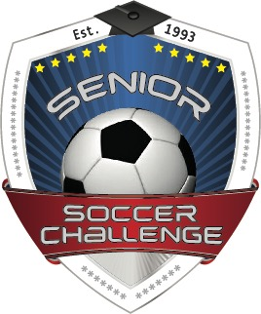

SPONSORSHIP DONATION FORM

Name: _________________________________________________________________________
Address: _______________________________________________________________________________
City: ____________________________________State: ___________Zip: __________________

Level of Donation:
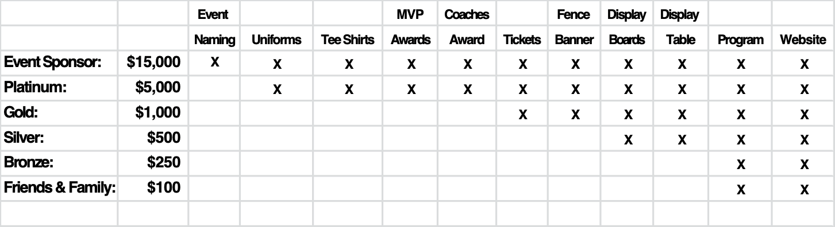

Checks made payable to: Senior Soccer Challenge
11132 Calluna Drive
Odessa, FL. 33556
727-409-0256

Senior Soccer Challenge is a 50lC3 not for profit organization. FEIN #59-3252720

